LIVELIHOOD DEVELOPMENT FOR HUMAN RIGHTS PROMOTION-SIERRA LEONE (LIDFOHRP-SL)
Motto: Promoting Livelihood Sustenance & tackling violence against women and Girls

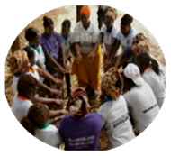
HEAD QUATER
222A Bai Bureh Road,
Congo Water Junction Wellington
Freetown-Sierra Leone; West Africa.
Email:livelihood_development2015sl@yahoo.com/ Livelihooddevelopment2015sl@gmail.com

DIRECTOR & ADMIN office
+23277272970/23225286474
Face book:
livelihood_development2015sl@yahoo.com

Use Your Hands Wisely to make a living

RE: SNAP SHOT OF OUR ACTIVITIES
Brief background of the organisation

Livelihood Development for Human Rights Promotion Sierra Leone (LIDFOHRP-SL) is an indigenous local voluntary organisation founded in 2014 but officially established and registered in 2015. It was founded in memory of and in continuation of a true local Philanthropist called Eye Kamara-Sierra Leonean. Eye had continually shown deep empathy about the appalling conditions of people living in abject poverty in the interior poorest part of the countries-Sierra Leone where she has visited and worked. Very close to her heart were women and Girls especially victims of domestic violence and those who still remain vulnerable to sustain their livelihood in their communities, with little or no access to essential support services and safety nets.
OUR VISION:

To lead communities where Women, Men and Girls can live, work and play to protect the rights of all.
OUR MISSION

To engage communities in “sustainable development initiatives through livelihood activities, human rights promotion intervention, gender parity and capacity building”.
LIDFOHRP-SL PROGRAMING

We work to facilitate holistic intervention of five thematic areas Prevention & education, Protection & economic empowerment, advocacy& policy influencing, Agriculture and emerging environmental related issues. Our Core activities from which the idea of holistic intervention was borne is Livelihood sustenance activities for women victims/survivors of domestic violence & youths and to Popularizing the gender laws of Sierra Leone and other international treaties including Domestic Violence Act 2007, Registration of Customary Marriage and Divorces Act 2007, Devolution of Estate Act of 2007, Sexual Offences Act 2012, Child Rights Act 2007, Maputo Protocols-2015 and National Referral Protocol (NRP). Our organization was established to promote the welfare of women, children and youth.
SUCCESSES:
Economic and social empowerment PROJECT for women (EASE)

“Most times women and girls are the most vulnerable in every crisis, especially in terms of livelihood sustenance in the household”. In an effort to respond to this call for attention, LIDFOHRP-SL has established 6 women groups and engaged them on a post-Ebola recovery livelihood project title “Community women savings and loan association (COWOSLA) within the western rural and urban districts in different communities. So far the groups have saved above Le 60,825,000(sixty million eight hundred and twenty five thousand Leones) or $ 10,137.5 within nine months and have stated the loaning phase of the COWOSLA components of the project cycle.
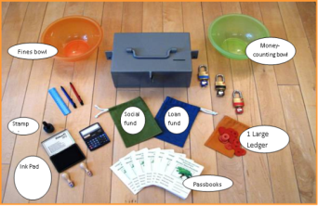
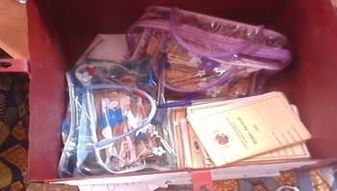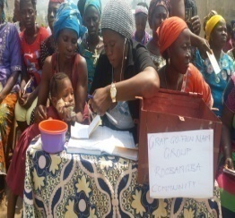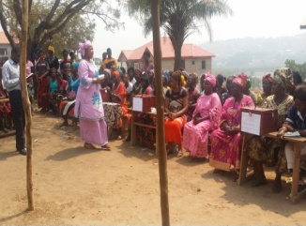
Six established groups posed for savings.
Beneficiary making her savings
Money saved for sustainable livelihood (loaning phase)
Economic empowerment kits

LIDFOHRP-SL SUPPORTING WOMEN VICTIMS/SURVIVORS OF DOMESTIC VIOLENCE ON SMALL SCALE BUSINESS START UP

When the term “business” is mention among vulnerable women, their thought focused on high capital intensive business for which they cannot fund. The training was centered on conducting informal local community needs (environmental scanning) in order to determine what their communities are interested to buy and consumed and invest with special attention on the average earning of members in their communities and to decide on the price and try to be flexible in the business changing environment . The training was also directed on narrowing their minds to community oriented type of business (s). This training workshop has given birth to what they refer to as COMMUNITY GROUP BUSINESS which is given them the opportunity to have access to not only loan, but their household cooking materials. (PHOTO)
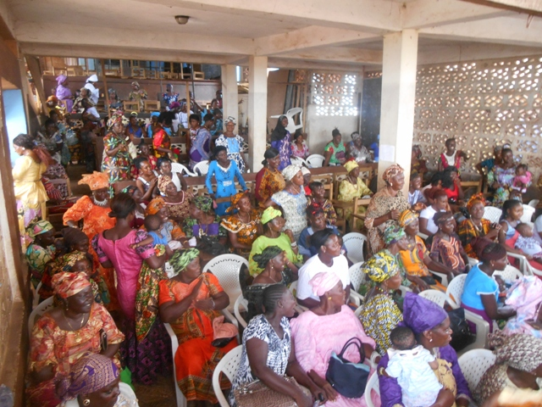
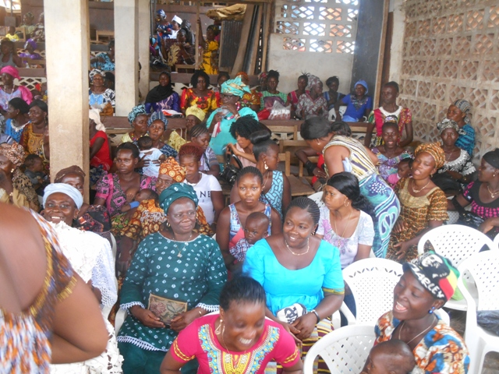
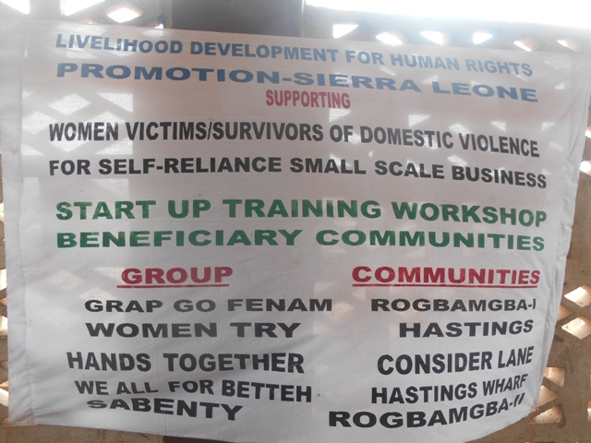

Beneficiaries of the community women savings and loan association turn up for the small scale business skills training workshop (capacity building)
Workshop banner showing beneficiaries group names and communities

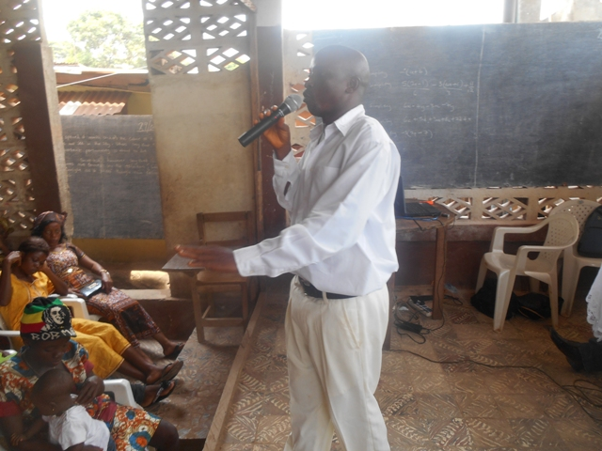
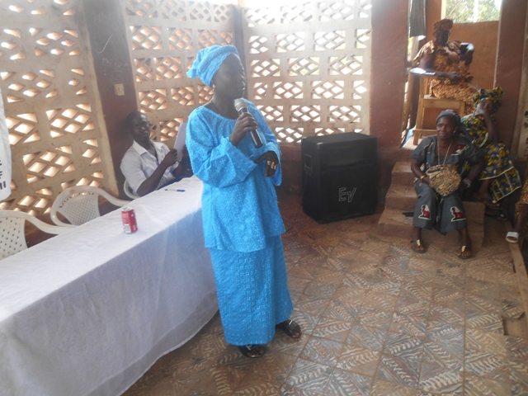
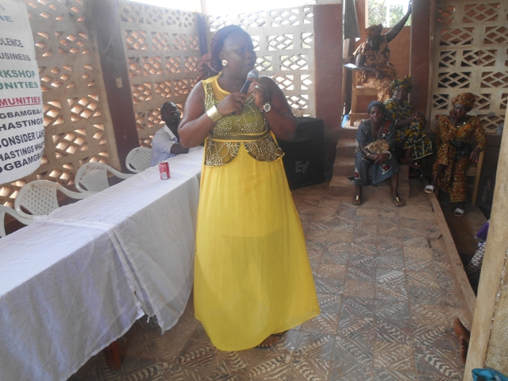
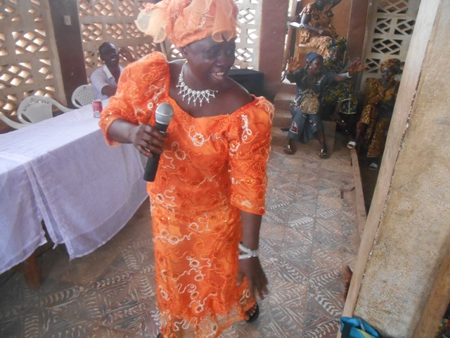
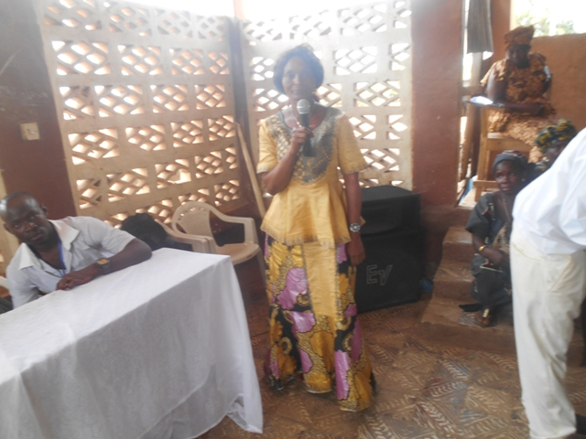
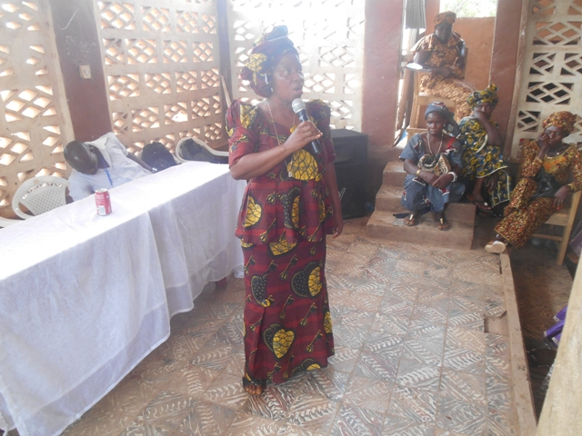

Chairladies of the COWOSLA GROUPS making statements of appreciation for the training workshop
EXECUTIVE DIRECTOR MAKING STATEMENT ON RELEVANT OF THE TRAINING

GENDER LAWS AWARENESS RAISING
GENDER LAWS AWARENESS RAISING
GE
GENDER LAWS AWARENESS RAISING

GENDER LAWS AWARENESS RAISING
GENDER

We have also been able to school community women on a project title Leh we know the domestic violence law. This project was implemented in Rogbamgba community which attracted 70 participant including stakeholders and some selected beneficiaries of the livelihood project-community women savings and loan association.
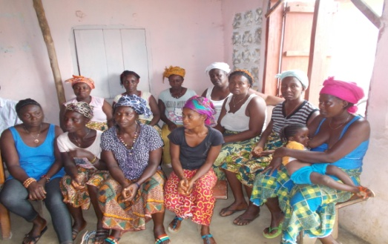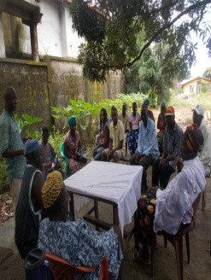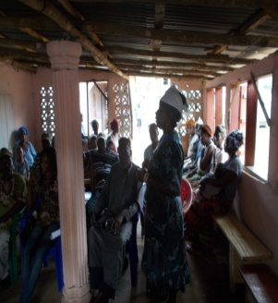
Cross section of domestic violence victims in our awareness raising
Participant making contributions about the devolution of estate act of 2007
CHILD EMPOWERMENT
CHILD EMPOWERMENT

CHILD EMPOWERMENT

Our effort to make quality child building a reality for all children (education sector), we have established partnership with five primary schools. LIDFOHRP-SL has implemented a project title one day school feeding and distribution of learning materials and non-food items (NFT) to 302 children in one of our partner school (Lighthouse pre-primary school) at Rogbamgba community.(see photo)
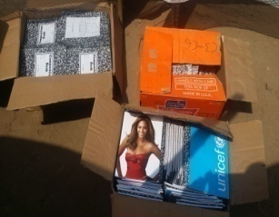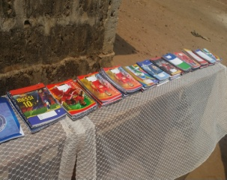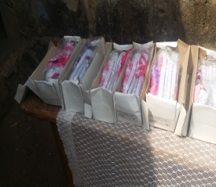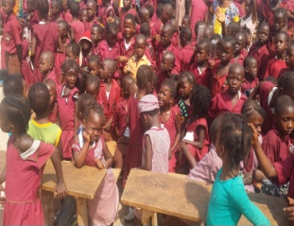
School Children awaiting distribution of learning materials
Cartoons of learning materials

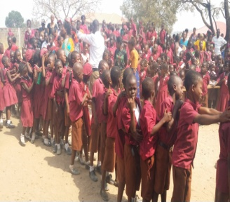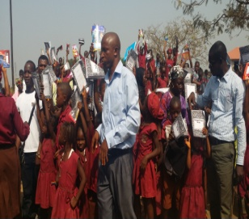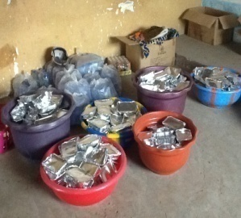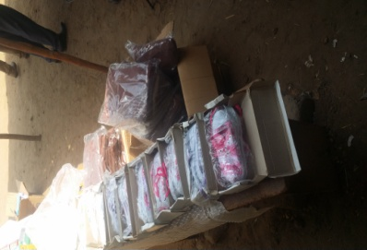
Children in a queue to receive supply
Other non-food items ready for distribution
Food is ready for distribution
Children jubilating with Director
CHILD PROTECTION

LIDFOHRP –SL have professionally handle a matter of an abuse girl child age four from Pujehun (more than 100 miles) from the capital Freetown. Hussanatu was taken away from her biological parents from Pujehun to Freetown to be taken care-of and later to be sent to school. The girl ended up falling in the hands of a wicked aunt who in most case beat her up for simply attending to the call of nature (visiting the ladies-toilet) at home. This practice had become habitual to the so-called aunt until the nieghbour had to raise alarm and a tip-off was given to our organization. In our preliminary investigation, we realized that she was even locked up in a rusty dark kitchen at 11:00pm on January 2nd 2016 and left to perished. We took up the matter with the family support unit of the Sierra Leone police at K-step police station-calaba town and a medical paper was issued and referred to the Rokupa Government hospital. Diagnosis was done and the medical paper was endorsed. Medicines where prescribed and bought by our organization (copy available)
The matter was reported to the ministry of social welfare gender and children’s affairs and the child was taken from the aunt and handed over to LIDFOHRP-SL for temporal custody while family tracing was on going. Hussanatu lived with us for two months.
LIDFOHRP-SL was finally able to trace the biological father of the four years girl at the end of February 2016. Hussanatu was handed over to the probation section of the ministry of social welfare, gender and children’s affairs in the presence of her parents for onward handing over of the girl to her biological parents.
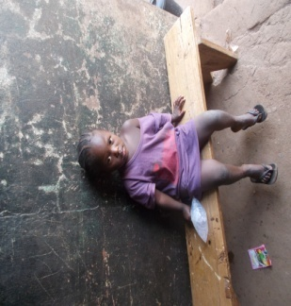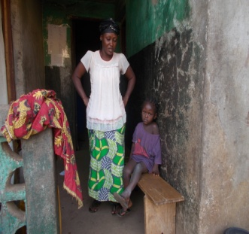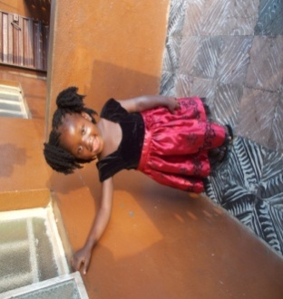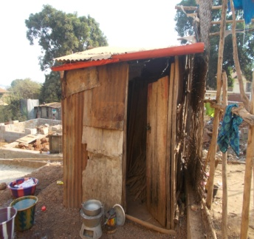

Wusanatu after spending 2 months with LIDFOHRP-SL center
Wusanatu age 4 in her abuse status
The dark kitchen where she was lock up after 11:00 pm to spend the night-2nd Jan 2016
Wusanatu and her perpetrator

WOMEN PROTECTION

The rate of domestic violence against women (DVAW) in communities is on the high increase in the western rural district. The most alarming among other abuses is the physical violence which has to do with the men throwing their mighty strength to cause mayhem on vulnerable rural women with barely little or no structures to seek redress. (See sample photo)
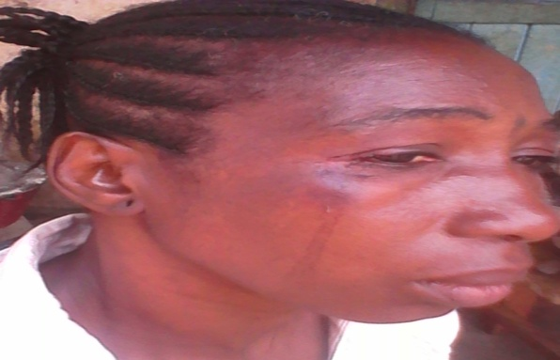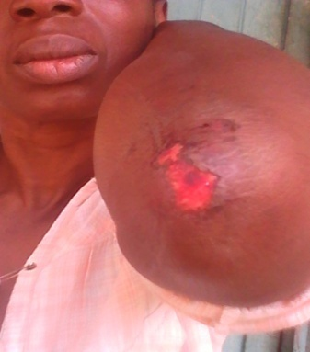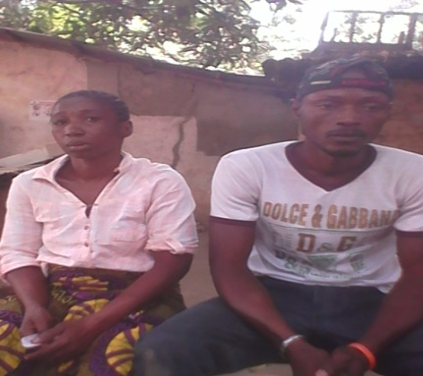

. This woman (see photo above) said, quote “if I attempt and the system fails me, then I have no other option but to return back home and wait for my untimely death” end of quote
“Not that I do not have good ideas as a way out from my trouble, but who will guide and support me. My parents knows what is happening but they keep-on asking me to stay, even when I am suffering and dying slowly”
From LIDFOHRP-SL perspective, most of these women (victims/survivors of domestic violence) look determined to make tough decisions. But convincingly, they require a reliable and functional system, a system that will support them all the way towards achieving their next option in life.
LIDFOHRP-SL appropriate option is to engaged them on livelihood sustenance leading to sustainable socio-economic activities to give them confidence in order to take control of their own destiny through livelihood activities. Another area of challenge is helping them with legal support for stubborn perpetrator in order for them to be aware of the negative impact of their activities.

CHALLENGES-What we have not done:

We have not been able to facility the group discussion series (DGS-leading to inclusive decision making at home) and the business development skills training components of the community women savings and loan association.
We have more children to support with learning materials and other child empowerment support kits.
Women and child empowerment and human rights committees have not been established in order to introduce domestic violence free dialogue initiative in communities as a structure to promote sustainable CO-existence living and prevent human rights abuse in communities.
LIDFOHRP-SL lack predictable funding and continuous resource mobilization. This will most likely constrain the development and implementation of ongoing project activities around our core intervention approaches. This will subsequently inhibit the spade of work of our organization stride towards plainly seeing the desired tangible effects on women and girls in
Sierra Leone
STAFF STRENGTH

LIDFOHRP-SL currently maintains a staff of 7 volunteers with the relevant work related experience. These volunteers have been working since October 2015 and have contributed immensely towards the starting-up process of the program activity implementation and have continued up-to-date
APPEAL

In this vein, LIDFOHP-SL as an organization is humbly seeking an ongoing association and collaboration with your ‘Humanitarian Aid organization’. In this way, LIDFOHRP-SL and your organization can expect a timely response to tackling “Violence against women and girl at HOME & communities

THANK YOU

