**HERE IS A LOOK INTO THE REAL RURAL LIVING IN MANAFA DISTRICT**

**{PART ONE}**

Looking at the reality of life in rural areas of Africa, it’s hard to belief how these people even survive in those rather harsh conditions of life where everything in life seems rather unreachable.

Clean water, health care, education, proper sanitation, access to basic needs such as sugar, soap even salt seems like a dream to the local people in rural communities. Its urbsade to note that these people are well contented with their way of life because it’s like there is no hope for them. Thereby staying in agony in their hopeless state for the rest of their lives

They basically survive on motherland nature of the soil and God’s mercy who gives them the rain which enables them to cultivate or carry out subsistence farming. Over 86% of Uganda’s population depends on subsistence farming.

They grow bananas, maize, millet, beans, cabbage and rare animals to give them milk, labour and manure. The garden is the only way to survive. In case a family member falls sick, they get a bunch of banana and carry it all the way to the markets for sell. They move for over 15km in search of markets to sell their produce. Their gardens are the only source of hope to the rural people. Their gardens provide food for their families, provide more crops for sell in order to buy salt, soap.

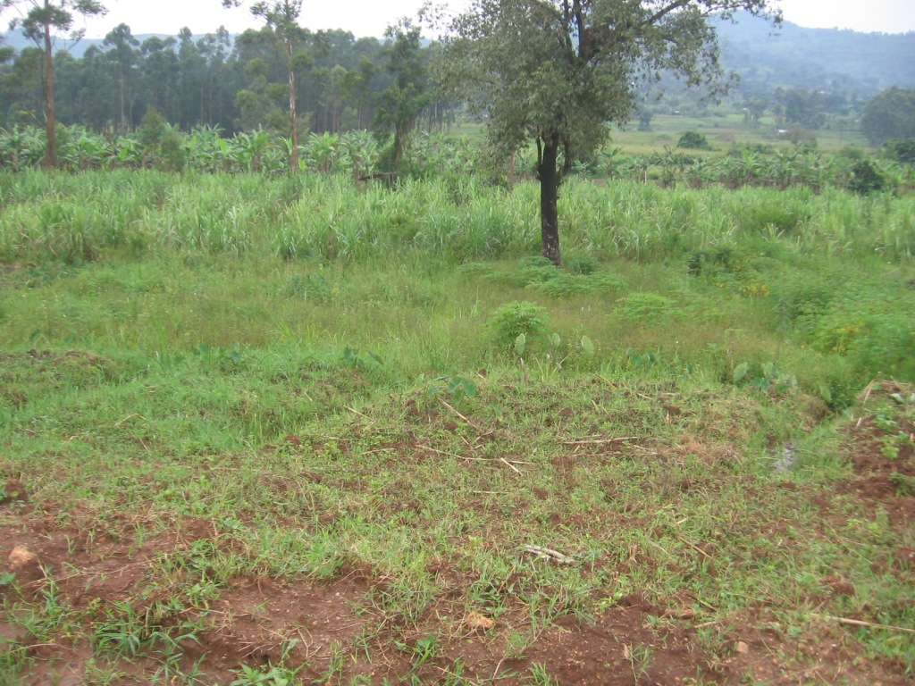

This is how a garden looks like.

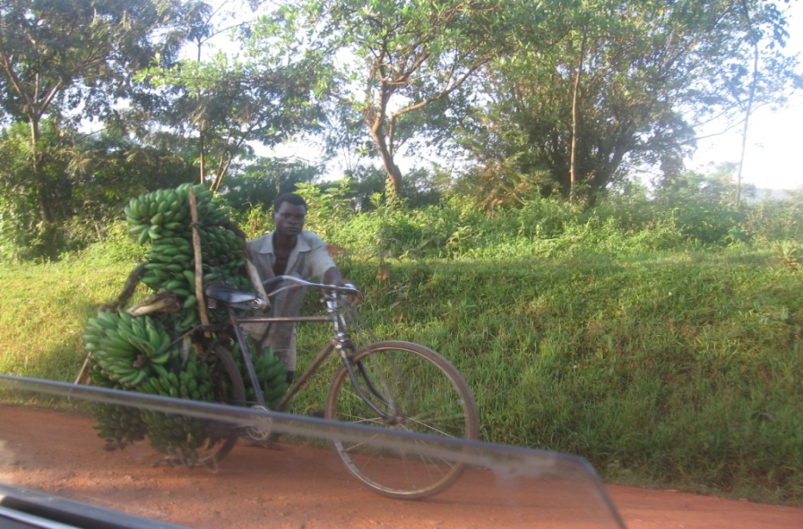

A farmer riding for 20km to sell his bananas. Below is a village market that is open only on Thursday

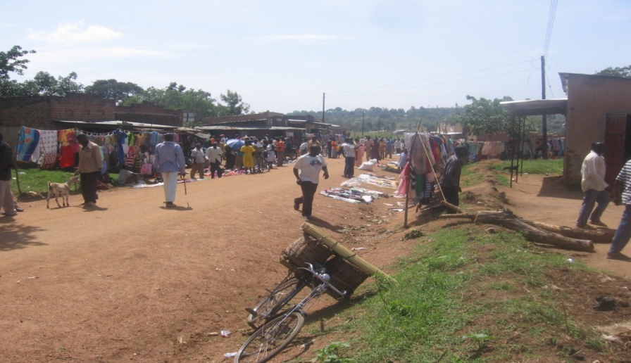

**WATER**

Water in the African rural setting is very unsafe but the locals just use it since there is no other option. The water is normally got from streams, wells, river and lakes. The water is used by both the people and the animals. The animals drink from the same source with people. The water is untreated and unprotected so its one big cause of diseases, like, bilharzias, typhoid, diahorea, dysentery. Since people are not frequently sensitized, they don’t see the need of boiling drinking water

Rural people walk for long distances to access the water because the water bodies are located in far areas that are not near the homes.

Storage containers are not cleaned and expensive to afford. They therefore can’t afford these containers so they do their washing in the rivers, lakes, streams which also serves as their bathrooms then some water is carried home in clay pots and linking jerricanns.

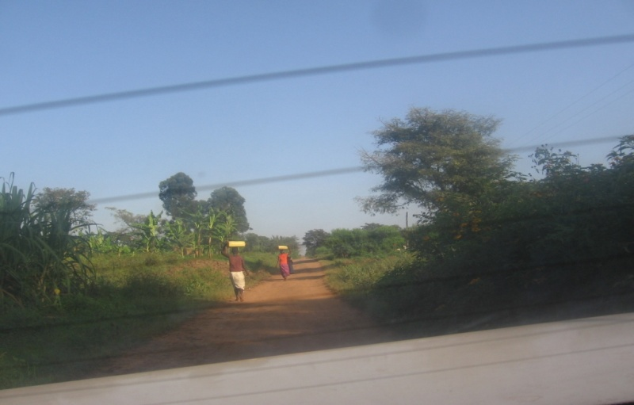

A que of women carrying water on their heads from the river to their home.

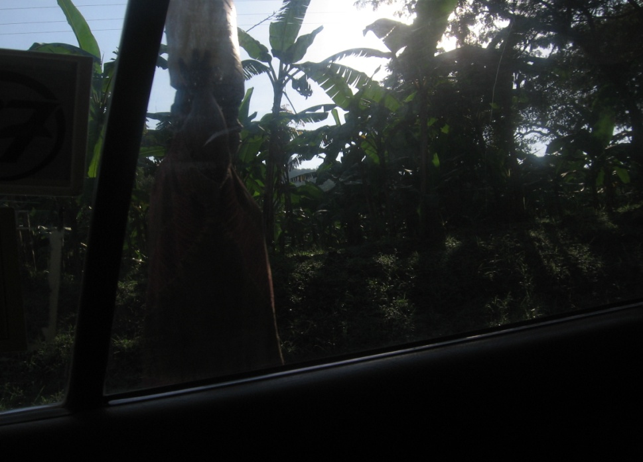

**WEATHER**

These rural areas are located in the tropical regions of the east of Uganda. It’s a mixed kind of weather with a lot of rain and sun precisely. This weather is favorable for agriculture but the people in these areas are faced with a lot challenges as a result of this weather. The transport systems are very poor due to muddy and dusty roads, inaccessibility of agricultural seeds, fertilizers, modern farming tools all these factors make it difficult for a farmer to benefit from his garden. Sometimes landslides, flooding are a barrier to better farming.

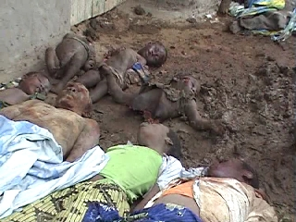

The landslides in bududa that buried homes and a hospital.

**SOCIAL LIFE**

The rural setting in Africa still holds the value of real social life. These people still value their norms and customs and above all are relationship and friendship. Leadership is enthroned to elders normally because of their experience in different events of life.

In case of disagreements, fights, misconduct, the elders step up and council the parties and punish the guilty. Village people help each other in times of death, sickness; the whole community come and gives a helping hand. They collect food, firewood, water as a sign of solidarity. They love it when the moon shows up. They all sing, dance and drink their local brew under the moon.

Young boys are initiated to manhood through circumcision and its accompanied by a traditional dance called kadodi.

Life is also difficult for the widows, orphans since they are considered cursed. They are discriminated and mean nothing to the community. Rural people normally have one meal a day due to their schedule. They wake up at 6; 00am to go and dig and return at 12pm thereby skipping breakfast, prepare launch and have it at 3pm. So it’s really difficult to have a balanced diet.

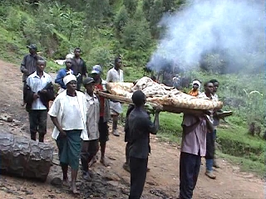

This is how patients are carried to hospitals. A group of people carrying a patient to hospital

The hospital is 10km away from this village. They have to run with the patient to the hospital before he she dies.

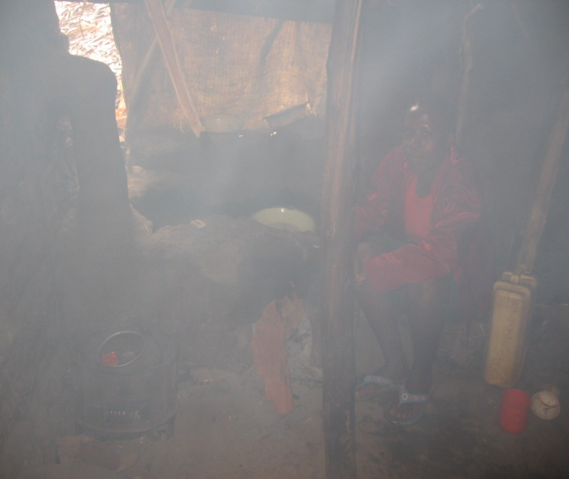

This is a girl preparing launch in the kitchen filled with smoke which is harmful to her health but that’s how she prepares meals daily.

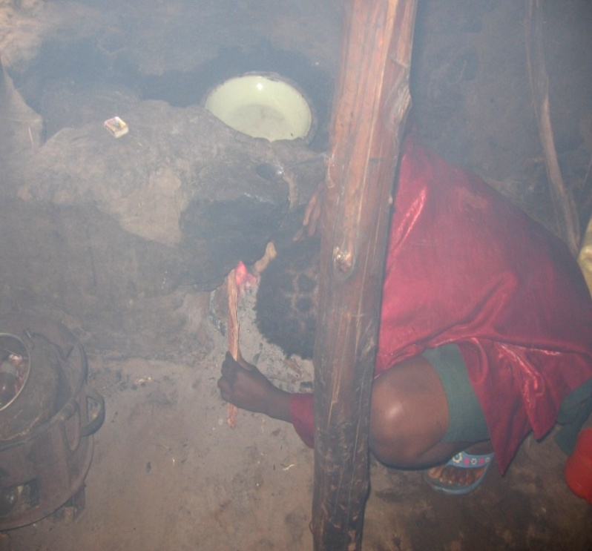

A girl lights up the cooking stove locally made.

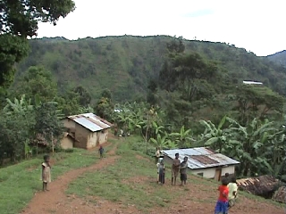

A group of children having fun after launch at 4pm.below is a busy market that happens once a week.

Below is a market place. This market happens once a week so everyone has to buy and use what he or she has bought for the week. If the market day is there and you do not have money to purchase, then you have to wait for another week to purchase what you want. Shopping has to be made that day so that you don’t need anything during the week before the market comes back.

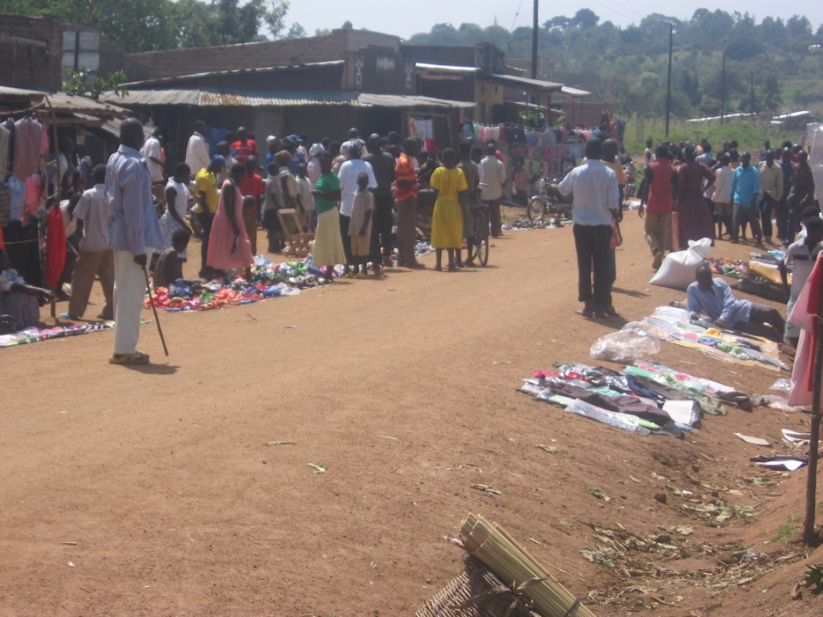

**SANITATION**

Sanitation conditions in rural are very poor. These areas are very filthy because of the conditions of life they live in, people share houses with goats and hens which result in very poor living conditions.

People can’t access soap so they can’t wash their utensils, well, wash their clothes and their own bodies and this has caused skin diseases to the community.

**LABOUR**

When a man has many wives it becomes easy to cultivate since many wives work on his farm so he does need to hire labor for this farm. In this marriage setting all the children belong to the man and the women have no right over the children even if the parents separate the children must stay with the man. Women in the rural setting don’t have a say at one time they were stopped from eating chicken because of the rural beliefs.

**EDUCATION**

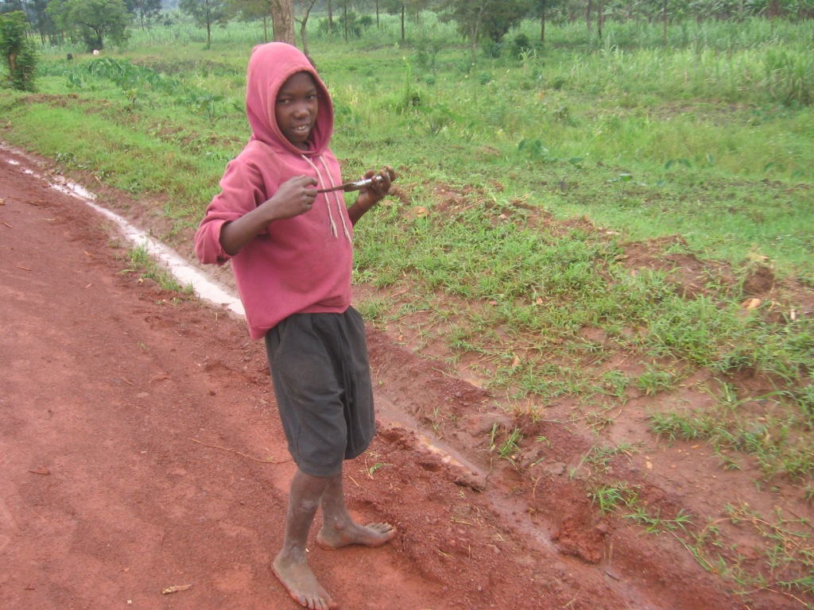

Here is boy who moves from home with a knife and on his way to school he branches to the garden to get sugarcane and have it for breakfast before reaching school.

In rural areas education is affected so much due to a number of reasons;

Lack of scholastic materials. Many children can’t afford the prices of scholastic materials so they end up not being able to stay in school.

Lack of uniforms. Many parents in rural areas cannot afford to buy uniform for their children like the boy in the picture above is going to school without uniform and books. Due to aggregate poverty the little money they get helps them to sustain their lives and not to purchase uniforms.

Long distances. There are very few schools constructed by the government and they are located far from the homes so children have to walk very long distances to reach school so weak and tired and remember they have no breakfast. It really takes effort to study in rural areas. Many give up due to those hardships they go through to study

Under paid staff. Teachers and other members of staff are underpaid so there is no moral to teach the children. They get to school late and even fail to teach since they are not motivated by a good pay. They sometimes go on strike as the kids sit in class without teachers

Food and water. A hungry child cannot learn anything I guess. So with no food and water for these children education is a myth. It’s just can’t workout.

Beliefs. Most of those kids have it in mind that education is not so important since you can finish to study and lack employment. Therefore it takes time to convince them to go to school.

Some of the children want to study but since their parents have passed away due to HIV/AIDS they don’t have any opportunity to go to school.

Compiled by Isaiah namboyo