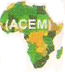

AFRICAN COMMUNITIES EMPOWERMENT
P. O. Box 1749, Mbarara, Uganda. Tel: +256 773 127934. Email: acempowerment@yahoo.com

Introduction
Humanity throughout history struggles to reach the best of their potential and achieve their full measure of happiness, but the varying situations in which we are born and forced to grow have classified us into fortunate and unfortunate, vulnerable and non-vulnerable. AIDS pandemic, wars, poverty and other disasters have left many people in shackles of vulnerability. This leaves humanity with no choice but to take urgent, fast and enough action to reverse the situation of the affected humanity. The world’s generosity is the answer to this crisis.
African Communities Empowerment is a non-profit, non-governmental organization that is dedicated to empowering and uplifting the vulnerable and marginalized people in communities through Education, Training and promotion of Human Rights. The organization is legally registered with the Ugandan N.G.O Board under the Non-Governmental Organizations statute of 1989.
The work of this organization is all directed at enabling beneficiaries to achieve the best of their potentials and giftedness to live more meaningful, productive and fulfilling lives. Community groups that we define as vulnerable in accordance with the vision of the organization include the poor population, orphans, youth, women and the girl-child.
The organization operates in the Western Districts of Uganda and is currently implementing 5 projects including Marian Institute, Marian Girl’s High School, Mbarara – St. Beniz Campus, St. Joseph’s Education Centre, St. Paul’s Girls Primary School, Rural Vulnerable Children Empowerment Program and Computer Literacy & Internet Technology for Rural Schools. Our work is implemented with an ultimate vision of freeing the people we serve from shackles of poverty, ignorance and illiteracy.
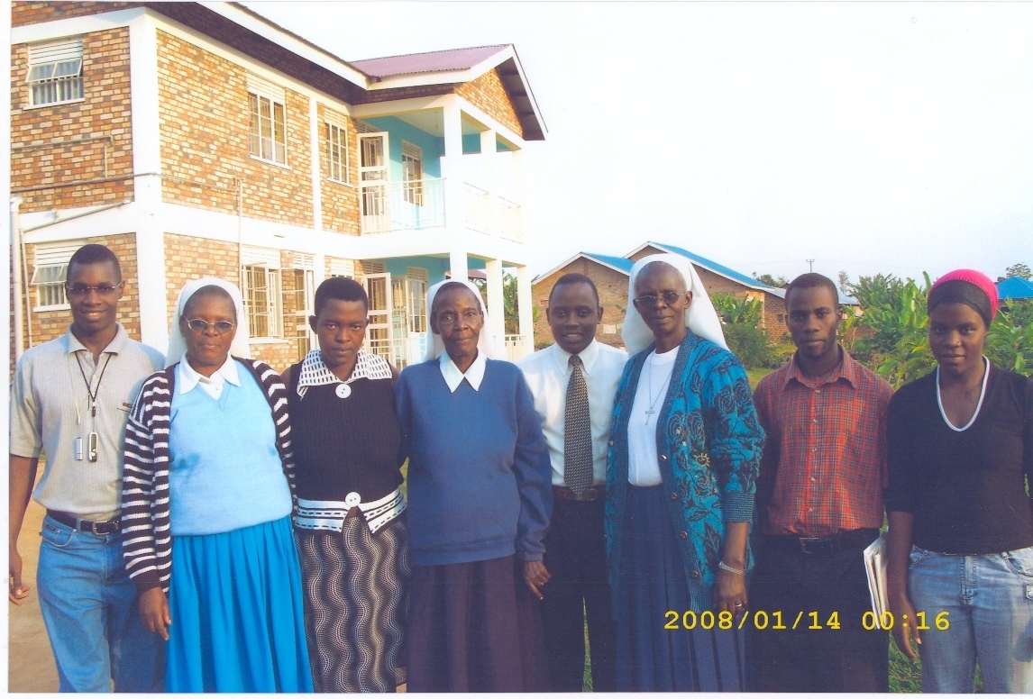

MEMBERS OF THE IMPLEMENTATION TEAM

Projects Description
Listed below are brief descriptions of each project and some photos of their activities.

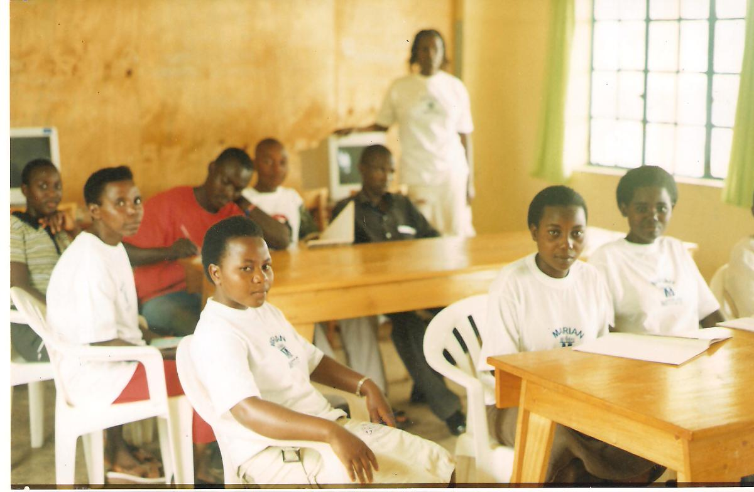
- Marian Institute
Marian Institute is a Vocational Training Centre implemented by African Communities Empowerment. The project empowers girls/women by giving them skills and practical knowledge that enables them to become employable and self-reliant. Beneficiaries of this project include single mothers, divorced, widows and girls of the poor. Currently, the project has an enrolment of 79 trainees. Since establishment in 2004, an average of 70 trainees is passed out every year. The photo above shows some beneficiaries of this project attending instruction.

2. Marian Girl’s High School, Mbarara – St. Beniz Campus

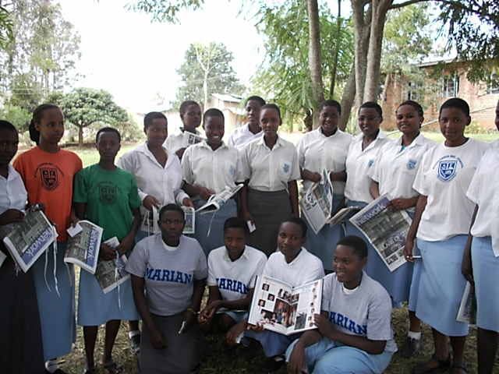
Marian Girl’s High School, Mbarara – St. Beniz Campus is one of the projects of African Communities Empowerment. The school is located in Kashari County of Mbarara District, Uganda.

The school has been planned and is be ing implemented in the catholic tradition and the spirit of the Order of Servants of Mary with St. Philippe Beniz as its Patron Saint. The school commits resources to the education of young women, teaching them to be leaders and lifelong learners in a society where their talents and faith will give hope to the world.

The school runs in close collaboration with Marian High School, Omaha – Nebraska with an ultimate objective of facilitating a Cross-Cultural Exchange Program between the girls attending both schools.

- St. Joseph’s Education Centre
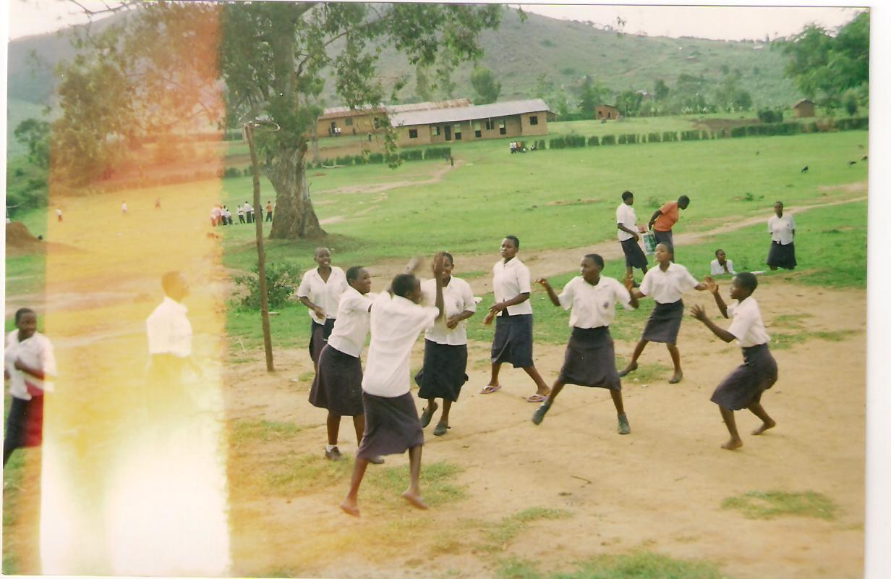
St. Joseph’s Education Centre was established in 2003 as an initiative of the organisation to educate the children of the poor in the area. Since establishment, the school recruits children of the poor from within the region and beyond for formal education and prepares the beneficiaries to sit for Ugandan National Examinations. The school also runs a program of adult literacy that gives a second chance to widows, divorced, those girls who are forced out of school because of early marriages, premature pregnancies and other cultural practices. An extra effort is made to rehabilitate beneficiaries of this category and integrate them into the main stream learning system of the school. Currently the total enrolment of the school is 340 beneficiaries. 300 of these are girls/women while 40 are boys. The photo above shows some beneficiaries of this project in class.

- St. Paul’s Girls Primary School
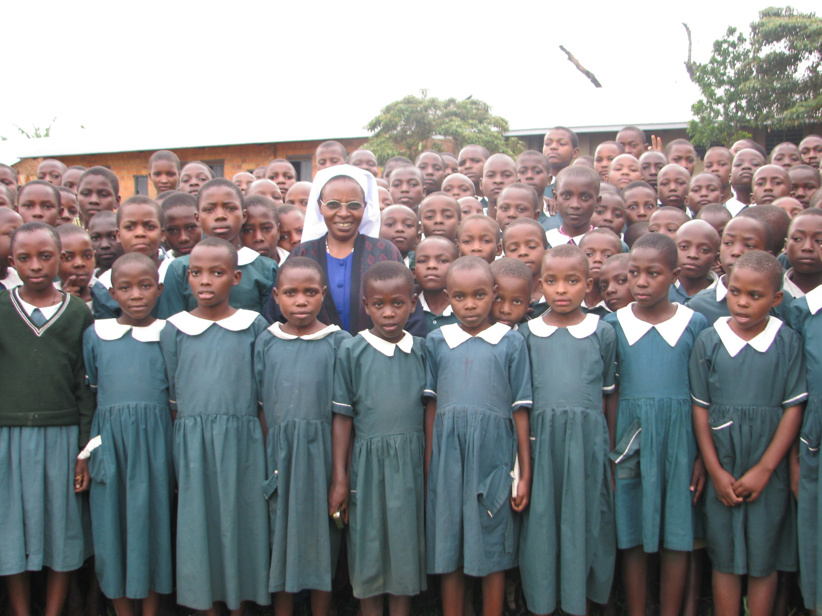
St. Paul’s Girls Primary School was initiated to empower the girl-child through education. The project offers formal primary education and its overall mission is to educate girls by laying a basic foundation and knowledge and skills that they require to go through life meaningfully. We promote gender equality as we endeavour to narrow the traditional unfair gap between women and men in our communities. The school currently has an enrolment of 400 girls. These are children from poor households and most of them have been orphaned by HIV/AIDS scourge and are being looked after their relatives. The photo above shows some of the girls at school during extra-curricular activities. Beyond the playground are the structures of the school.

- Rural Vulnerable Children Empowerment Program
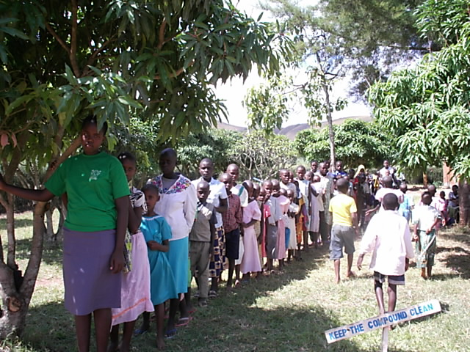
Rural Vulnerable Children Empowerment Program is a social transformation program that is aiming at making a breakthrough for rural vulnerable children and orphans by empowering them through education. We are using a network of our friends around the world to attract compassionate people who volunteer to select children of their choice from the displayed list and sponsor their education. The photo above was taken during the registration of some beneficiaries of the program.

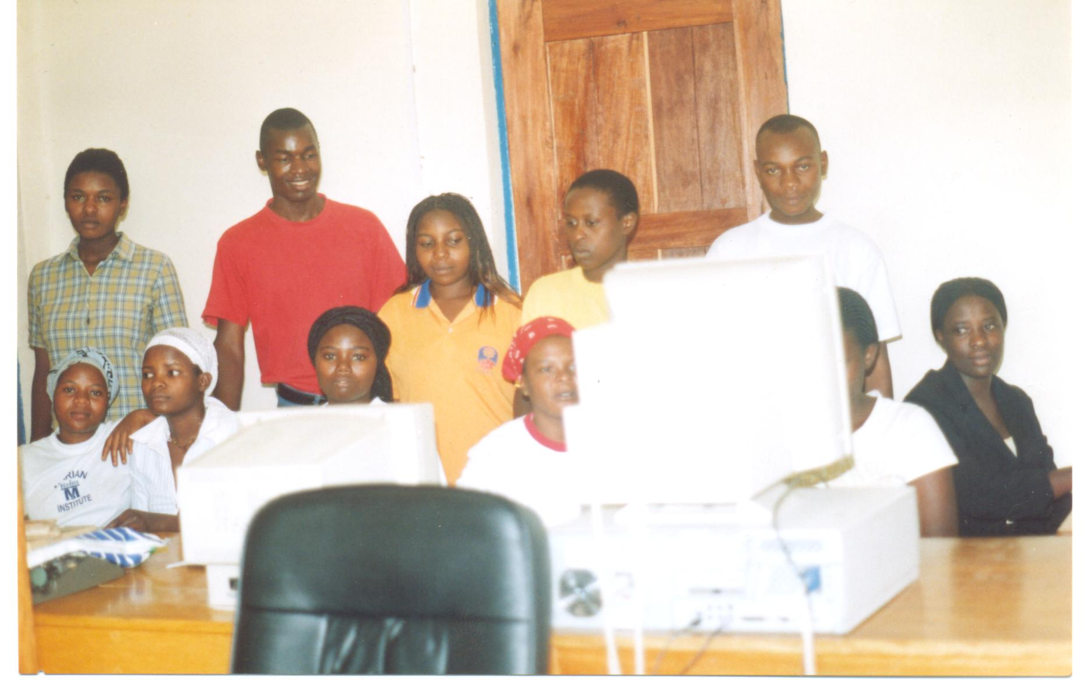
- Computer Literacy and Internet Technology for rural schools
Computer Literacy and Internet Technology for Rural Schools is a project that ushers schools in the rural area where our organisation serves into modern Information and Communications Technology (ICT). The project is one of the strategies chosen by the organisation to close the digital divide between the developed world and our area. Computer and Internet technology has profoundly changed the lives of people around the world and our people must not miss out on the opportunities afforded by this technology. The project establishes Computer Resource Centres in the selected beneficiary schools, and initiates the school into a sustainable usage of ICT and integrates it into the school system to support students and teachers for intellectual development and learning enrichment. The photo above shows some students of Kibona Secondary School attending an ICT lesson in the Lab established by the project.

THANK YOU
We seek the generosity of the world in form of material, financial support or voluntary services. We need support to sustain the work we have began, boost, empower and expand it to enable us counter the ever increasing need in the communities where we serve.

