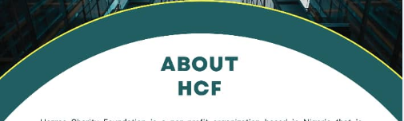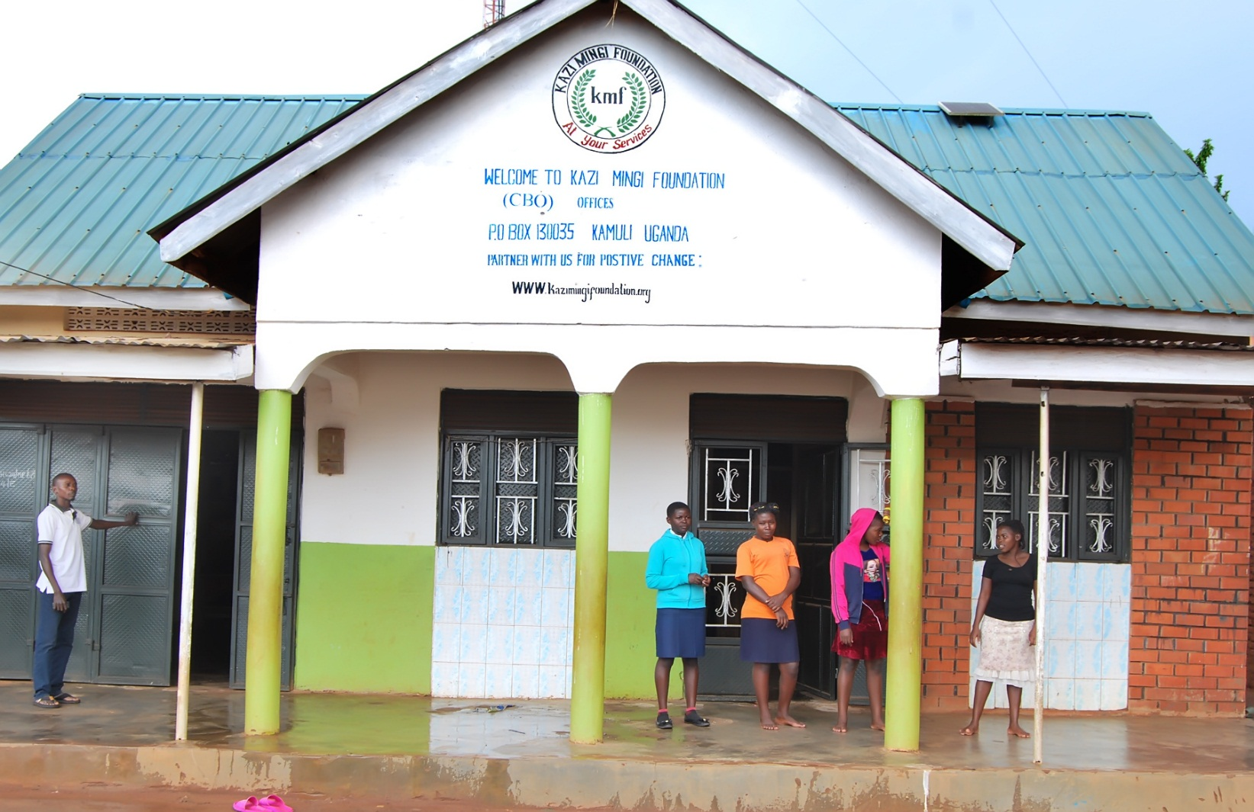

ABOUT KMF

ABOUT KMF

**PROFILE OF KAZI MINGI FOUNDATION**

Kazi Mingi Foundation (KMF) was established in 2023 as a non-profit Community Based Organization which is registered with the district Non-government organization monitoring committee as a community focused initiative under registration number KDCD/0123/111503. After seeing such a great for the needy orphans, vulnerable children and youth with local communities (villages) in Uganda, God revealed to Mr.Mwavu Manisuuli (Kazi Mingi) after his community research paper that he submitted to qualify for his first bachelor Degree of arts in social and social administration to reach out to the needy of the neediest (poor needy kids, orphans and vulnerable youths) in local poor communities (villages) who are abandoned, destitute and poverty stricken. And this was due to many NGOs that were established to towns/the city of Uganda and local villages are left out where the most vulnerable groups are found.



VISION & MISSION

**Vision:**

To create a world where no one is left behind and everyone has access to basic education, health, and economic opportunity.

Kazi mingi foundation empowers the less privileged through education, health, and economic opportunity, We work to change policies and laws that effects the lives of the people we serve. We collaborate with other organizations, government and stake holders to maximize our impact and create lasting change.

**MISSION:**

The mission of Kazi mingi foundation is to improve the lives of the less privileged through sustainable development and charitable assistance. We do this by providing education, healthcare, and economic opportunity to those who need it most. We believe that every person has the right to a life of dignity and opportunity, and we are committed to making this a reality.

**AIMS AND OBJECTIVES**

Empowerment and Collaboration:

To empower the less privileged and provide charity humanitarian assistance, we aim to collaborate with NGOs, Government bodies and stakeholders to enhance our outreach and impact.

Education and Youth Engagement:

To educate youth, women and under privileged individuals in vocational skills. We are committed to engaging youth in self – reliance activities and community development.

Alleviation and Economic Empowerment:

To contribute to poverty alleviation by constructing social amenities in rural communities. We focus on economically empowering poor youth, women, and widows through training them vocational skills.

HOW WE WORK

Kazi Mingi Foundation works in partnership with local communities, local and national government, and other NGOs to ensure that our programs are relevant, sustainable and effective. We use participatory approaches to ensure that communities are involved in all stages of the project cycle, from design to implementation to evaluation. We also emphasize capacity building and skill development to ensure that communities can continue to benefit from our programs after we leave. Finally, we place a strong emphasis on monitoring and evaluation to ensure that our programs are achieving their objectives and having a positive impact on people’s lives.

The number one work objective of Kazi Mingi Foundation is to empower communities to create lasting changes. We believe that people are the key to their own development, and we work to build their capacity to address the issues they face and create a better future for themselves and their families. Our programs focus on improving people’s health, education, livelihoods and access to basic services, and we work to ensure that these improvements are sustainable and have a lasting impact.

The number two work objective of Kazi Mingi Foundation is to foster partnerships and collaboration between different groups. We believe that collaboration is essential to achieving sustainable development, and we work to build relationships with local and national governments, other NGOs, the private sector, and the community itself. Our goal is to create an environment where all stakeholders are working together towards a common goal, and where everyone feels a sense of ownership and responsibility for the success of the project.

The third and final objective of Kazi Mingi Foundation is to ensure that our work is evidence-based and data driven. We believe that the best way to achieve sustainable development is by basing our programs on solid evidence and data. We use a variety of tools, such as surveys, focus groups, and impact assessments to collect data and measure the impact of our programs. We also share our findings with other organizations and the public, in order to improve development practices and achieve better results for the people we serve.

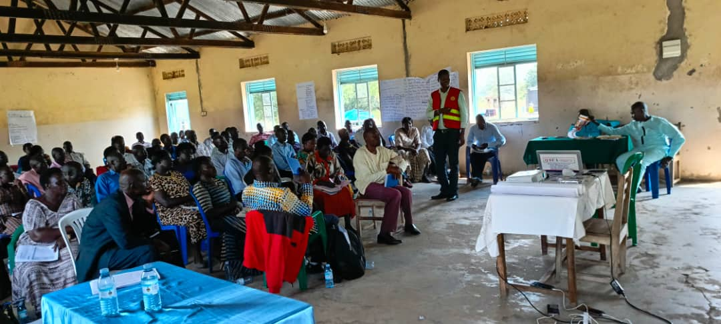

**KMF`s Basic Principles of Conduct.**

* KMF believes in upholding its constitution that clearly defines issues of membership, sources of funding, networking and more.
* KMF in self-help participation and identifying ones’ potential.
* KMF believes that every human being must live a good quality life.
* KMF believes in strict accountability of all resources, funds, materials and time.
* KMF works to unite staff towards achieving the mission by providing an attractive working environment and helping them in developing their careers and personal talents as well as security for employment.
* KMF works with Government policies to achieve goals that affect the life of vulnerable children and out-of-school youth.
* Any gift or donations which improve the status of our organization are welcome.

**Ownership, Government and leadership.**

The policy frame work of KMF is guided by fully registered memorandum and articles of Association and clientele; KMF operates in organs which include:

1. **Board of directors.**

Composed of founder members and individuals invited on basis of adequate professional experiences in era of relevance to KMF. They include: Board of chairman, treasurer and 5 Board members, the executive director is the secretary to the board. The Board formulates policies and supervises implementation of program.

1. **Secretariat**

The Head office is in Kamuli and headed by the executive director. The secretariat is responsible for the day-to-day implementation of policy and programs of KMF; the executive Director is supported by program coordinators.

1. **KMF Training Centre**

KMF Centre is where operational activities are carried out. The center is headed by the project coordinator assisted by the sectional head instructors and trainers who train vulnerable children and out-of-school youth in different skills offered by KMF two support staff assist them.

**Program Focus and Coverage**

KMF`s geographical coverage is Kamuli district, However Kamuli district is engulfed by Luuka, and Buyende districts. These areas are reached by family tracing and resettlement. Child advocacy and community outreach, formal and Non-formal education HIV Prevention, treatment, care and adolescent sexual reproductive health (ASRH). KMF resettles children are reached by that process national wide.

The direct beneficiaries of KMF program are vulnerable children and out-of-school youth and children who are working in hazardous conditions. KMF`s activities are preventive and rehabilitative in nature. Hence, both preventive and rehabilitative approaches are used.

**A wide range of activities are under taken by KMF.**

1. **Preventive Activities:** These include: - reaching out vulnerable children and out-of-school Youth in their ca-coons, and through carryout counseling sessions, family tracing and community sensitization.
   1. Community mobilization and the training on child and youth related issues as stipulated in UN convention on the rights of the child and the Ugandan youth policy.
   2. Training the out-of-school (vulnerable children, out-of-school) aged 15 and above, in vocational training and life skills.
   3. Coordinating and supporting campaigns and actions on child and youth right both at national and community levels.
   4. Active research and survey on specific issues affecting the out-of-school youth and children.
2. Publication on children youth experiences.
   1. Education support by paying fees and stationary for vulnerable children both at primary and secondary levels in the operational areas of KMF.
3. **Rehabilitation Activities:** These include
   1. Resettlement and re-integration of teenagers and vulnerable children with in them communities or their families before and after training.
   2. Vocational Skills training and life skills.
   3. Post training and group formations for the trained youth.
   4. Financial support to some of the trained youth to start their own businesses/enterprises for self-sustenance.

**KMF`S Distinctive Competences**

KMF has excelled in the following areas and sufficient potential, skills and experience to undertake any skills mentioned above. It has also developed personnel as well as other resources for their successes. These areas are; child frame recovery, counseling and resettlement, vocational training for disadvantaged children and youth, community mobilization and training and provisional of sustainable credit to needy families to sustainable resettled, re-integrated children and youth after training and rehabilitation.

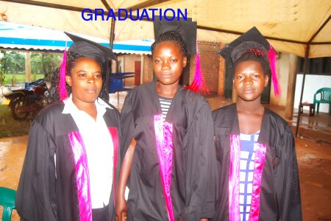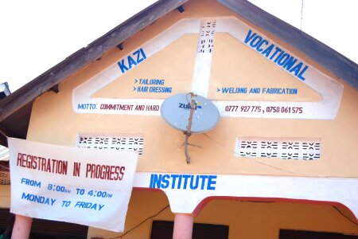**Achievements to Date**

**Vocational Skills training.**

KMF has established vocational skills center for the vulnerable children in Kamuli District. At this center, the following trades are offered:

* Tailoring and sewing
* Hair dressing and beautician.
* Bag making.
* Shoe making.

So far 150 youths aged between 19 and 35 years (girls and boys) are benefiting from the programs each year. Special considerations are made to cater for educational needs of the individual child. KMF divides its children in three categories i.e. (P.3-P.5, P.7 and S.1-S.4 dropouts) those below aged 14 years are encouraged to go back to the basic formal education and those between 19-35 years undertake vocational skills training.

KMF uses two languages in instructions i.e. local and English to enable the trainees to pass on the skills, also in other case, instruction charts and materials are designed to facilitate the process. Life and copying skills are integrated in the training program. Trade testing is carried out at the center by Directorate of Industrial Training (DIT) to enable them get a recognized certificate

**Alliance Building.**

We need to network with all organizations/groups institutes through exchange of experiences, material support, financial for the benefits of our target group and staff.

**Challenges**

* KMF needs to get a long-term funder to support its strategic plans to fulfill its long term planned activities and programs.
* KMF has tried to reach-out to its target groups, as indicated above. There is need to strengthen its fundraising program both locally and internationally to sustainably manage its planned activities/programs.
* Inadequate funding has hampered its development plan (having a sustainable and equipped center). There is need to strengthen and implementation of planned activities as many look for better opportunities elsewhere in the NGOs sector.
* Empowering the trained youths with equipment and material or loans is still a problem.
* There is need to strengthen this area to have a successful story of the rehabilitated   
  children and youth.

OUR PROJECT GALARY

Skills 4 her program

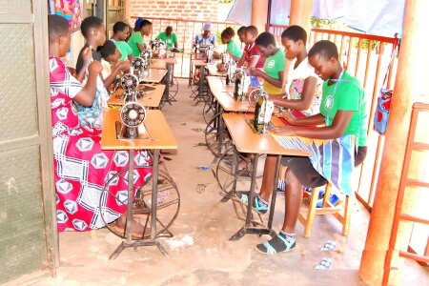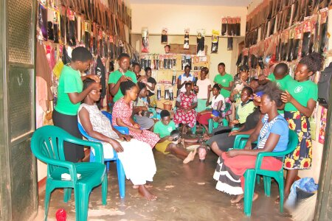

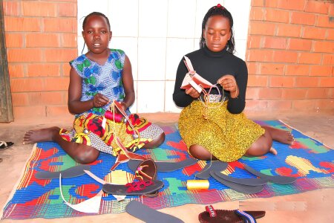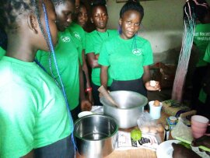

Education

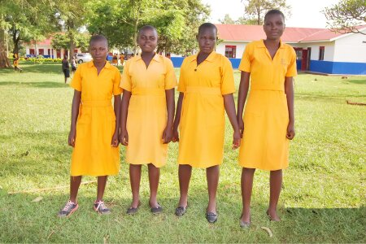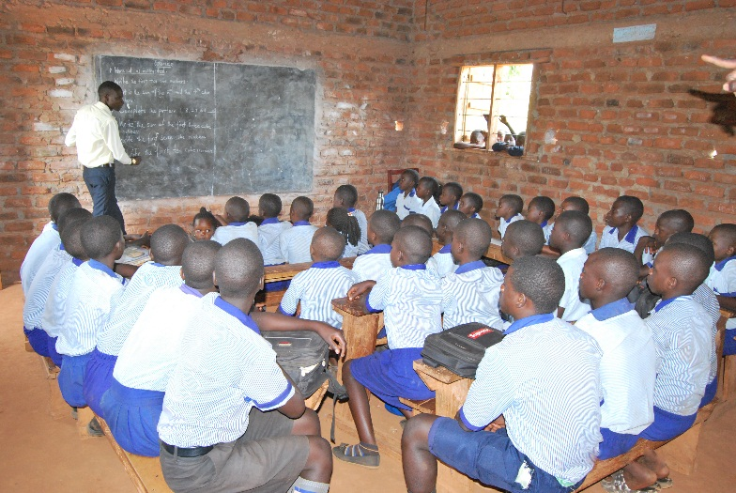

GET IN TOUCH

Connect with us to amplify impact. Your inquiries, collaborations, and support are vital. Together, let’s make a difference and create positive change for those we serve.

Address

Butamirike Zone, Makoka Parish,

Namwendwa Subcounty, Kamuli District, Uganda

Phone

+256758061575

E – mail

foundationkazimingi@gmail.com

OUR BANK ACCOUNT

STANBIC BANK UGANDA LIMITED

SWIFTCode. SBICUGKX

Stanbic Branch:

Kamuli branch

Beneficiary organization Account Number:

0140516714101

Beneficiary Organization Name:

Kazi Mingi Foundation

FOR WESTERN UNION:

Please send the money to:

Name: Mwavu Manisuuli

Country: Uganda

City: Kamuli

Tel: +256758061575

Please after sending, you will send us the following information in order to get the money:

The senders names:

MTCN code

Test question

Test answer

Country/City

Amount sent: